Simplifying volunteering - Districts
How we'll simplify the way we volunteer together
for positive volunteering everyday

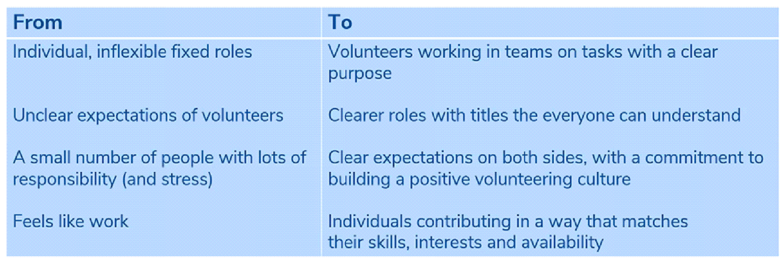

Why we have an urgent need for change…
We need to make sure how we volunteer is right for current
and new volunteers, as well as for young people

At the moment:

- We have too many roles, which can be unmanageable, fixed and too often feel like work

- Our range of roles can be hard to understand, and expectations when someone joins or moves role are often unclear. They can put people off from joining - ‘I couldn’t do what you do’

- We have a small number of people with lots of responsibility (and stress) placed on them. This can often make volunteering tip into feeling like work

What will stay the same
- Our structures will still be arranged in Sections, Groups, Districts and Counties, as well as broadly the tasks that happen at each level. For example, section teams will still deliver programmes to young people

- People will still be able to volunteer in the area that is of most interest to them, such as working with young people, delivering excellent governance, or giving support to other volunteers

Picture a world where volunteering is:

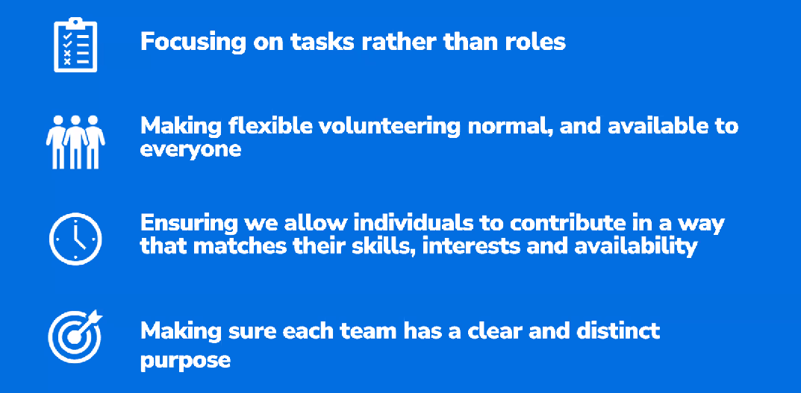

A fresh approach to volunteering with Scouts
Whilst our current approach to volunteering has served us well for many years, we need to adapt so we stay relevant and to help us attract more new volunteers, whilst ensuring volunteering with scouts is enjoyable for everyone.

During the national consultation, thousands of people shared what’s great about volunteering with scouts (and what’s not). Based on this feedback, we’re making changes.

Going forwards, the way we volunteer will be structured around these key principles:

- People typically like to volunteer as part of a flexible team. We know that many people across the country are doing this really well today. We want to embed this everywhere and make it easy for everyone.

- We need to have a clear purpose for every team in Scouts. Naturally, getting such clarity results in a change to the responsibilities of some teams. Whilst change is rarely easy, it will put us in a stronger position moving forward and will be easier for new volunteers (including those who haven’t yet joined) to understand.

- The language we use to describe our teams and roles needs to be stated in plain English to ensure its easily understood by all volunteers and by those outside of Scouts.

How our volunteers work together in teams
To make flexible volunteering a reality, we need to make it easy for people to volunteer in a way that suits their skills, their interests, and their availability. To help this happen, we’re no longer working to a role description, and instead sharing a set of tasks amongst a team of volunteers. It’s down to the team of volunteers to agree who does which tasks, and it’ll change over time as people join and leave the team.

Some teams might start off with only one or two people. But by being flexible about how we ask people to volunteer, we’ll make it easier for new people to join in.

Instead of role descriptions, each team now has a team description. There are two types of tasks listed here:

- Tasks for the whole team – All team members take part in these tasks and must have, or develop, the skills associated with these tasks

- Allocated tasks – The team leader ensures that one or more team members has the responsibility and skills for these tasks

Here’s an example:
- Hannah is a Team Leader. They do whole team tasks 1-3 and allocated task 1.
- Arnold is a Team Member. They do whole team tasks 1-3 and allocated tasks 2 and 5.
- Jess is a Helper. They do allocated task 6.
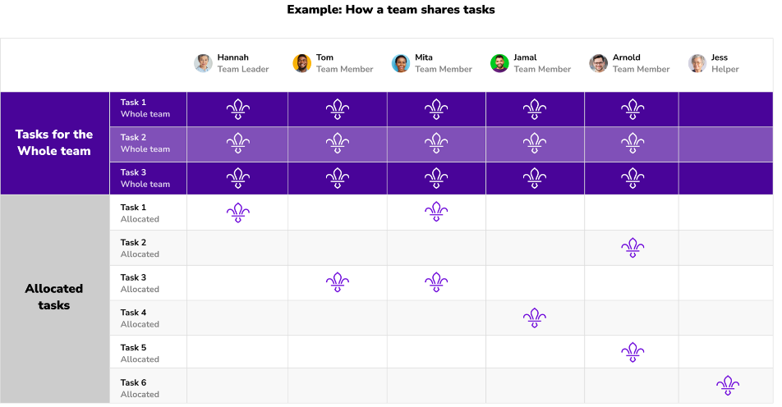

Key changes

Volunteering that works for everyone
Everyone can volunteer flexibly. The way you volunteer depends on the skills, time, and interests you bring to the team.

Clear purposes
The purpose of Trustee Boards (previously known as Executive Committees) will be made clearer to help us align with charity regulations. Trustee Boards will be smaller than the previous Executive Committees.

Team-based volunteering
We will have Team Leaders and Team Members. You can still be called Akela (for example), but these terms make it easy for people to volunteer flexibly.

Scout Active Support Units (SASUs) will be linked with the most relevant team. For example, a hillwalking SASU will become a sub-team of the Programme Team.

Share tasks among a team
Lead Volunteers (previously known as Group Scout Leaders, District Commissioners, and County Commissioners) will share their tasks among a team. For example, a designated Safeguarding Lead can respond to safeguarding incidents in Districts and Counties.

Clear responsibilities
Districts will be responsible for helping Section volunteers learn the skills they need and support their programmes. This’ll give close support to the volunteers who need it and removes duplication between Districts and Counties. (To be clear, we use the word ‘County’, but this includes Area, Bailiwick, Branch, Island and Region).

A 14-24 Team Leader will be responsible for Explorers, including Young Leaders, and Network.

A clear statement about volunteering with Scouts
“Our volunteering culture” is a statement of the culture and values we wish to foster and develop and provides clarity about the volunteering experience and culture we offer to current and potential volunteers, as well as what we expect of them.

“Our volunteering culture” is intended to be shared and made available to all existing volunteers and new volunteers as they join and be used during regular one-to-one meetings when discussing a volunteer’s experience.

Point your phone’s camera at the QR code to view the latest draft of the volunteer culture statement

How we work together in Scouts
Within scouts, we work together to deliver our shared ‘programme focussed’ goal whilst also looking after our volunteers. In the table below, we show how each part of the scouts contributes towards providing safe, fun, enjoyable and high-quality programmes for young people.

Organisation | Purpose
Section | Delivers the programme.
Group | Maintains an effective and motivated group of volunteers across the Group’s Sections, whilst ensuring the Group is well regarded in their local community.
District 14-24 Team | Maintains an effective and motivated group of volunteers across the Explorer and Network Sections, whilst ensuring the 14-24 provision is well regarded in their local community.
District | Leads Scouting across the District, enabling volunteers’ development, enhancing Sections’ programmes and providing operational support.
County | Leads Scouting across the County, enabling volunteers’ development (with focus on those in the County teams, including District Lead Volunteers), enhancing Sections’ programmes in ways which are better delivered at scale and providing operational support.

Keeping the programme at the core of all that we do
Our programme is predominantly designed and delivered by Section Teams in partnership with young people. All our volunteers either deliver the programme, or support those who deliver the programme. We must demonstrate that every volunteer contributes to the delivery of a safe, fun, enjoyable and high-quality programme, and should challenge any volunteer team which does not meet this test.
An overview of our new ways of volunteering
Lead Volunteers
Group, District, County teams
plus Nation and UK HQs
Section Teams
Trustee Boards

The structure of these teams will need to vary to suit local situations. Some Counties and Districts will find it helpful to use sub-teams to give specific focus to a collection of the team (e.g. a climbing sub-team of the Programme Team, or a campsite service sub-team of the Support Team). In addition, multiple Counties and/or Districts can share some functions or teams. In this case, the relevant Leadership Teams remain accountable for ensuring the teams continue to meet their needs.

What leading a team means
Each team has at least one Team Leader or Lead Volunteer. They work with Team Members to share tasks out and make sure the team runs smoothly.

Create a positive team environment
- Agree Team Description tasks with Team Members by considering their skills, interests, and availability.
- Make sure the team puts young people at the heart of what they do, so they can create inspiring teams and brilliant programmes.
- Make sure the team is open and inclusive, and adapt team activities and tasks to be accessible to everyone.
- Make sure everyone in the team is safe and following safeguarding procedures

Help volunteers find what they need
- Help Team Members find learning and networking opportunities.
- Encourage Team Members to share what’s happening in the team and find out where they might need support.
- For Lead Volunteers in Districts and Counties, make sure volunteers have the permits or accreditations they need to carry out specific, allocated tasks (where relevant).

Reflect and review
- Set up regular team self-reviews (at least once a year) to give everyone a chance to reflect on successes, and plan for the future.
- Carry out individual reviews with each Team Member. For Teams, they’re held by a member of the Group Leadership Team (for Squirrels, Beavers, Cubs and Scouts) or 14-24 Team (for Explorers including Young Leaders, and Network).

Attract and welcome new volunteers
- Help recruit new volunteers (with the Leadership and Volunteering Development Teams) so there’s always enough people in the team.
- Make sure new volunteers are warmly welcomed and complete their Core Learning.

Your district structure could consist of four areas of work or functions:
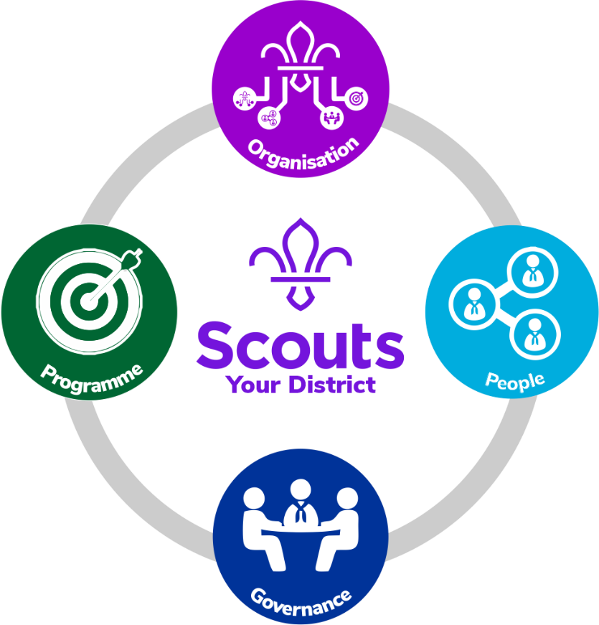

Each function consists of several teams:
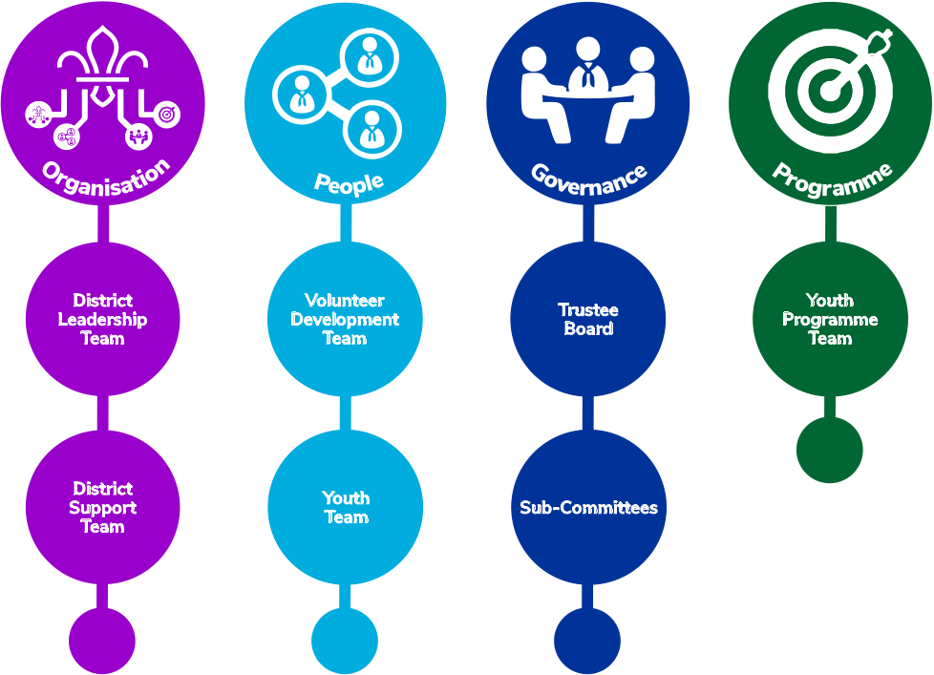

Providing practical support
This support structure will help deliver practical support that is accessible to all whatever their team or role.

- support for the programme, including the sections, camping, international opportunities,
and adventurous activities
- growth and development of the movement in our groups, units, and the district
- delivery of the association’s adult development and learning programme
- the implementation of the policies and rules of the association
- relationships with other organisations and bodies
- support for safety and safeguarding
- incident management
- helping young people take part in decision making at all levels
- recommendations for adult recognition, decorations, and awards
- advice on financial and administrative matters, particularly relating to charity trusteeship
- providing an effective chain of communication between scout groups, explorer scout units, scout network, districts, county, region, and national headquarters
- ensure that young people are meaningfully involved in decision making at all levels within the district

Opportunities created
Working together in defined teams (and as one team), with a common purpose and with a clear direction. Your district can deliver the best support and results and:

- encourages the development of scouting in our local communities so that more young people have the opportunity to experience scouting
- provides support for all our adult volunteers so they feel recognised, valued, and take pride in their scouting
- has an active and focused structure that will develop and maintain motivation through shared experiences; supported learning; strategic forward planning, clear governance and specific tailored support
- helps achieve high quality, exciting programmes of activity at group and unit, districts and county level, delivered by reliable, experienced sectional teams who have abilities and skills appropriate for the role
- provides development, learning and training opportunities for all our adults whether leading, supporting or managing local scouting, which is appropriate, effective, and innovative
- has a relevant, proactive resourceful, inspirational and supportive district team with effective systems for communication.

By doing this we will:
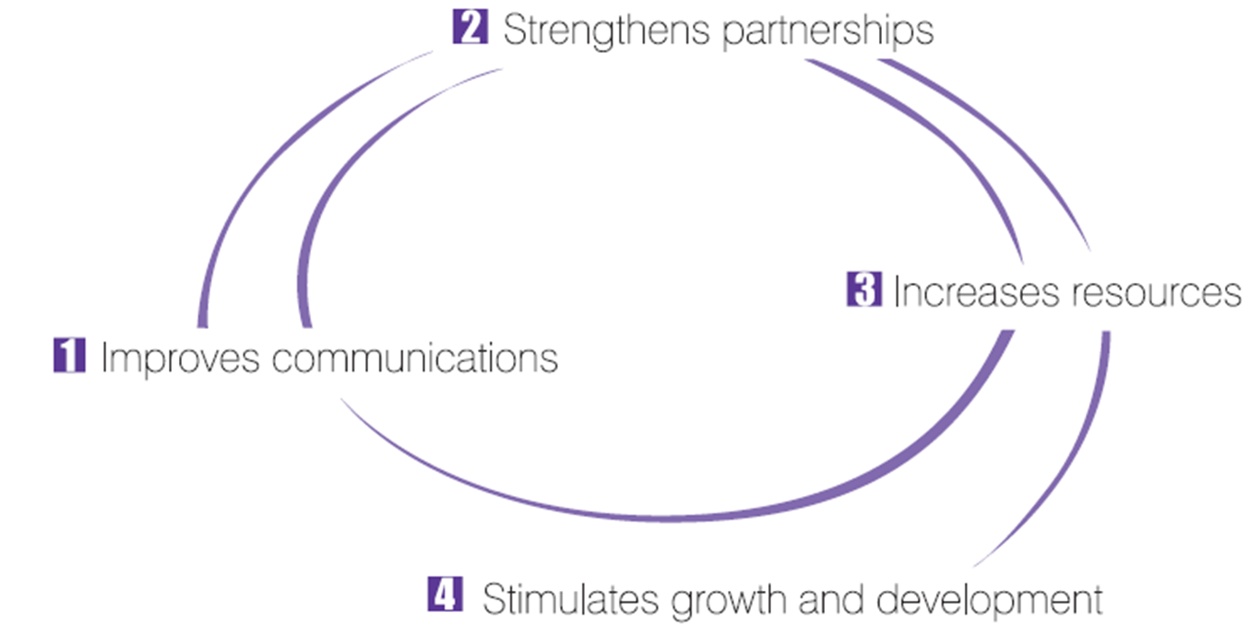
Heads of functions
Each of the functions has a ‘head of’ these are:
Function |  | Head of function | Teams
1 | Organisation | Lead volunteer for the district | - District Leadership Team  - District Support Team  - 14 – 25 Team
- 2 | - People | People Team leader | - Volunteer Development Team  - Youth Team
- 4 | - Programme | Programme Team Leader | - Youth Programme Team
- 5 | - Governance | County Chair | - Trustee Board  - Sub-committees

Team Leaders
Each team has a team leader:
Function |  | Teams | Team leader
1 | Organisation | District Leadership Team | Lead volunteer for the District
 |  | District Support Team | Lead volunteer for the District
2 | People | Volunteer Development Team | Volunteer Development Team Leader
 |  | Youth Team | District Youth Lead
- 3 | - Programme | - Youth Programme Team | Programme Team Leader
- 4 | - Governance | Trustee Board | District Chair
 |  | Sub-committees | Relevant sub-committee chairs

Sub-teams
Because of the range of support provided by our People and Programme functions some of the teams in these functions also have a number of sub-teams:

Function | Teams | Sub -Teams
Organisation | District Support Teams | District support team  (previously active support)
 |  | Premises or campsite support team(s)
 |  | Communications team
 |  | Any other support teams deemed necessary
People | Volunteer Development Team | Volunteer Journey Sub-team
 |  | Learning Sub-team
 |  | Young Leaders Sub-team
Programme | Youth Programme Team | Squirrel Scouts Sub-team |  | Traditionally these might have been known as district meetings for  each section
 |  | Beaver Scouts Sub-team
 |  | Cubs Scouts Sub-team
 |  | Scouts Sub-team
 |  | Explorer Scouts Sub-team
 |  | Network Scouts Sub-team
Governance | Sub-committees | Finance Sub-committee | Any other sub-committees deemed necessary
 |  | Premises Sub-committee

Sub-team Leaders
Each of these sub-teams has its own sub-team leader:

Function / Team | Sub-team | Sub-team leader
Organisation | District Support team  (previously active support) | Support Team Sub-team Leader
 | Premises or campsite support team(s) | Premises or campsite Sub-team(s) Leader(s)
 | Communications team | Communications Sub-team Leader
Governance  Sub-committees | Finance Sub-committee | County Treasurer
 | Premises Sub-committee | Premises Sub-committee Chair
Programme  Youth Programme Team | Squirrel Scouts Sub-team | District Squirrel Scouts Advisor
 | Beaver Scouts Sub-team | District Beaver Scouts Advisor
 | Cubs Scouts Sub-team | District Cub Scouts Advisor
 | Scouts Sub-team | District Scouts Advisor
 | Explorer Scouts Sub-team | District Explorer Scouts Advisor
 | Network Scouts Sub-team | District Network Scouts Advisor
People  Volunteer Development Team | Volunteer Journey Sub-team | Volunteer Journey Sub -team Leader
 | Learning Sub-team | Learning Sub-team Leader
 | Young Leaders Sub-team | Young Leaders Sub-team Leader

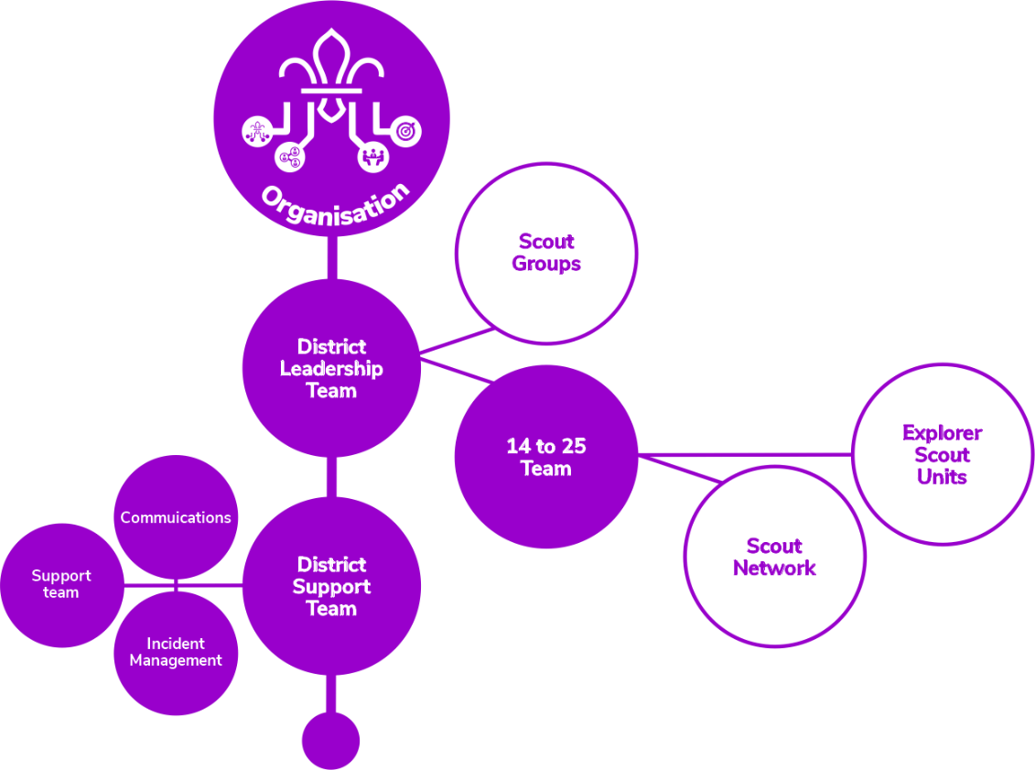

District Leadership Team
The District Leadership Team leads and inspires volunteers to give young people great experiences and skills for life. They make sure the teams in their District are organised, have enough volunteers, and can deliver a great programme.
- District Lead Volunteer
- District Youth Lead
- Lead Volunteers of each Scout Group
- 14-24 Team Leader
- Programme Team Leader
- Volunteering Development Team Leader
- Support Team Leader

Other volunteers in the team are called Leadership Team Members.

Tasks for the whole team
Make sure:
- District teams work well on their own (and together).
- Teams across the District are inclusive and reflect the demographics of their local area.
- Volunteers in the District’s teams fulfil their safety and safeguarding responsibilities, including keeping up to date with changes.

Volunteers are aware of Our Volunteering Culture, reflect on it, commit to it, and apply it in their teams.

Allocated tasks
- Help with recruitment to make sure there are always Trustee Chairs, Team Leaders, and Group Lead
- Volunteers in the District.
- Support the District Youth Lead to work with teams across the District and its Groups so they can be shaped by young people.

Other responsibilities

Make sure safeguarding, safety and data incidents and complaints are managed well. The Lead Volunteer will be responsible for responding to these, or for appointing someone else in the District to do this.

District 14-24 Team
The District 14-24 team keep its volunteers working well together and feeling motivated across Explorer (including Young Leader) and Network Sections. It makes sure the 14-24 Sections are respected and supported in their local community.
- 14-24 Team Leader
- Explorer Team Leaders
- Explorer Team members
- Young Leaders Team members
- Network specialist

Tasks for the whole team
Support Explorer Units, Young Leaders, and Network by making sure:
- The views and ideas of young people shape decisions in the 14–24 Team and its Sections.
- Section Teams help young people feel welcome and included. They make changes (when needed) so activities are accessible for everyone.
- The demographics of young people and adults reflect their local area.
- To meet the needs of 14–24 year olds in the District through the Explorer or Network programme, and creating opportunities to volunteer as a Young Leader.
- Develop our volunteers
- Work with volunteers to share skills between Section Teams.

Allocated tasks
Support the 14–24 Sections
- Make sure the Sections run smoothly.
- Work with Group and Section Teams to check there are Young Leaders in all Squirrel, Beaver, Cub, and Scout Section Teams.
- Make sure all incidents are reported in the right way.
- Look after first aid kits and accident forms for the Sections and their meeting places.
- Look after membership system records for volunteers and young people.
- Look after enquiries for joining and moving between Sections

District Support Team
The District Support Team provides tools and resources to help Scouts run smoothly.
- Support Team Leader
- Support Team Members
- Team Leaders of any sub-teams of the District Support Team

Allocated tasks
Support Scouts locally by engaging with the community
- Create and look after relationships with other organisations that can help Scouts grow locally
- Create a positive image of Scouts in the local community. For example, through local media
- Plan and run fundraising events when they’re needed

Open new provision
- Work with Groups and other District teams to open, close, or merge Sections (depending on local demand)

Support effective processes
- If asked to by the Trustee Board, help with finance admin to keep an eye on income and spend. This could include bookkeeping, paying expenses/invoices, and tracking income/expenditure against the budget
- Set up and look after email, web, social media, and web meeting systems for the District (and, if appropriate, for Groups and Units)
- If there are staff, make sure they’re properly managed and well recognised
- Look after youth joining enquiries across the District

Look after property and equipment
- Check bookings and maintenance for any District-owned property and equipment (including 14-24 Sections)
- Oversee meeting places for 14-24 Sections (whether they’re rented, leased, or owned)

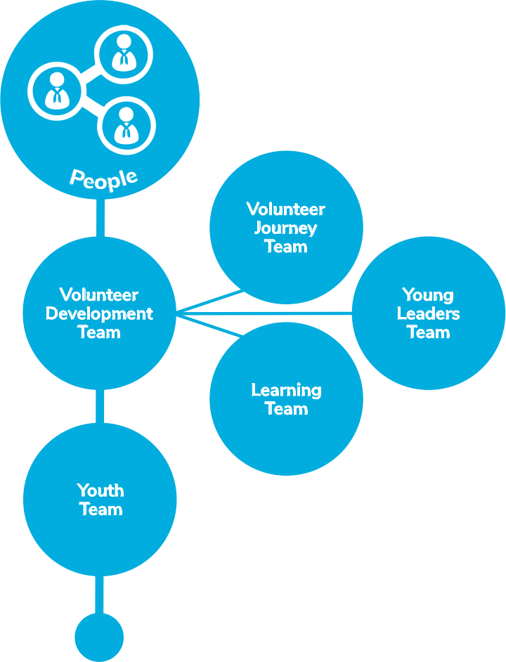

District Volunteering Development Team
The District Volunteering Development Team makes sure all volunteers in their District have a positive and enjoyable volunteering experience. They make it easy for people to join and learn new skills.
- Volunteering Development Team Leader  - Volunteering Development Team Members | - Volunteering Development Sub-team Leaders  - Volunteering Development Sub-team Members
Tasks for the whole team
- Ensure that “our volunteering culture” is effectively embedded across the District and its Groups
- Maintain relationships with groups and units
Allocated Tasks
Volunteer Development Team
Attract and welcome new volunteers to District and Group teams*
- Use Scouts branded resources to attract new volunteers
- Reply quickly and positively to possible new volunteers
- Make sure volunteers are welcomed easily and smoothly. Ensure that an accessible and consistent welcoming experience is delivered across the district
- Hold inductions with Group Lead Volunteers and other Group and District Leadership Team Members.

Make sure volunteers are well supported
- Help and encourage Team Leaders (including Group Lead Volunteers) to have regular reviews with volunteers in their teams.
- Make sure all District teams (including Group Lead Volunteers) follow our approach to safe volunteer recruitment, appointment, reviews, and processes for leaving Scouts.

Recognise volunteers
- Recognise and appreciate volunteers for their brilliant work, formally and informally.
Volunteer Journey Sub-team
Welcome conversations and screening
- Contribute to a safe volunteer screening process
- Support groups to carry out welcome conversations with new volunteers
- Support groups to help ensure volunteers meet relevant mandatory requirements, such as learning, references disclosure checks, etc.

Appointment reviews
Provide support to team leaders (including lead volunteers for groups), to carry out regular check-ups and reviews with the members of their teams
Volunteer Learning Sub-team
Help volunteers with learning
- Help volunteers and Young Leaders find and engage in opportunities for learning and development.
- Coordinate Scouts learning that needs to be delivered by an accredited trainer or facilitator – including coordinating and supporting the trainers.
- Use the learning delivery materials developed by Scouts (e.g. training sessions, workshops, activities, etc.), and make changes (when necessary) so activities are accessible for everyone.
- Help volunteers connect across the District and beyond to learn, share best practices
and overcome shared challenges.
- Set up learning opportunities with external organisations (if relevant and helpful).
- Make sure volunteers can be recognised for prior learning and experience, and have it credited in their records.
- Learn from people in other Volunteering Development Teams.
- As requested, support learners with their learning needs
Young Leaders Sub-team
- Help Young Leaders find and engage in opportunities for learning and development.
- Ensure learning opportunities for young leaders is in place
- Work with the district 14 to 24 team, groups and section teams to ensure there are young leaders in all section teams in groups across the district
* Our county development service provides lots of support, resources and guidance to support
you in achieving this task / responsibility

District Youth Team

Trustee Boards
The Trustee Board is a team of volunteers who work together to make sure Scouts is run safely and legally.

Together, Trustees make sure the charity is well managed, risks are assessed and mitigated, buildings and equipment are in good working order, and everyone follows legal requirements and Policy, Organisation and Rules (POR). Their support helps other volunteers run a fantastic programme that gives young people skills for life (and experiences they’ll remember forever).
- Chair
- Treasurer
- Lead Volunteer
- Appointed Trustees
- Co-opted Trustees
All Trustees are equally responsible, but they might decide to split the tasks between them.

Tasks for the whole team
Trustees work together to make sure Groups, Districts, and Counties:

Manage money well
- Have enough money for now and in the future. This means having a reserves policy and making sure fundraising takes place, if it’s needed.
- Have a budget in place. Trustees then agree how to manage the budget with other volunteer teams.

Follow Scouts policies and relevant legislation
- Follow POR, key policies and charity regulations
- Put measures in place to make sure Scouts’ safety policy is followed.
- Follow employment law, if staff are employed
- Create Trustees Annual Report and Statement of Accounts, and get it checked by an appropriate person. If they’re a registered charity, they’ll need to share it with the charity regulator.
- Hold an Annual General Meeting (AGM)

Look after buildings, insurance and property
- Look after records of ownership of property and equipment.
- Have the right insurance for people, buildings, and equipment.
- Make sure buildings and equipment are working well.

Manage risks
- Carry out regular risk assessments and put the right risk mitigations in place.
- Help the charity to operate well, today and in the future
- Work with Lead Volunteers to meet their charity aims.
- Champion Our Volunteering Culture, and make sure volunteers are aware of it, reflect on it, commit to it, and apply it in their teams.

In carrying out the above, Trustees also:
- Keep a record of Trustee Board meetings and complete any actions that are agreed.
- Recruit new Trustees.
- Co-opt Trustees onto the Board if they need people with particular skills or knowledge.
- Get expert advice, if needed. This could be on health and safety, managing money, buildings, equipment, or employees.
- Network with other Scouts Trustees to share knowledge and experience.
- Create sub-teams for specific activities, such as finances, if needed.
Allocated Tasks
Chair
- Lead the Trustee Board.
- Plan when Trustee Board meetings should take place and decide what to talk about at each meeting.
- Lead Trustee Board meetings and the Annual General Meeting (AGM).
- Liaise with Lead Volunteers.
- Lead recruitment for new Trustees.
- Support other Trustees by organising inductions, checking in to see how they’re getting on, and carrying out annual reviews.

Treasurer
- Look after finances, such as making sure all membership fees are collected and all payments are made.
- Share details about income and spend with other Trustees.
- Make sure Gift Aid is being claimed.
- Make sure proper accounts are kept and draw up policies on finance and investment.

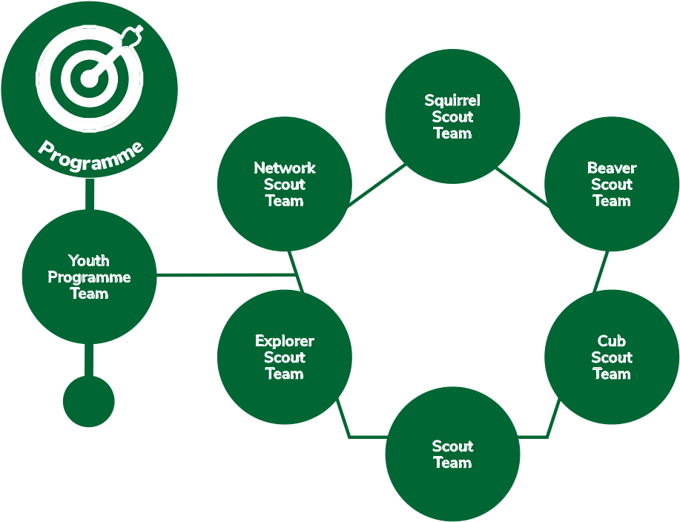

District Programme Team
The District Programme Team helps every section in the District run a safe, enjoyable and high-quality programme. To help do this, they bring Section Team volunteers together with activity experts.
- Programme Team Leader
- Programme Team Members
- Team Leaders of any sub-teams of the District Programme Team
Help Sections across the District work together

Help Section Teams run high-quality programmes
- Help volunteers with any programme changes, such as new badges and activities.
- Encourage international trips and activities.
- Support volunteers to include nights away in their Section’s programme.
- Help volunteers gain their Nights Away Permits.
- Keep an eye out for any learning that’ll help Section Teams deliver a fantastic programme. The Volunteering Development Team can then give volunteers opportunities to develop and learn new skills.

Facilitate programme networking opportunities
- Encourage Section Teams to share good practice across the District by creating opportunities to network.
- Help Section Teams access expert advice and support

Make sure:
- There are skilled people to support Sections’ programmes (in areas that volunteers may not be experts in themselves).
- Sections can access adventurous activities, either through permit holders or external providers.

Approve activities and permits (when delegated by the Lead Volunteer)
- Visits Abroad
- Adventurous Activity Permits
- Nights Away Permits

For current volunteers to have a good experience and attract new volunteers:
- We need our roles to be appealing to more and different people, including those who have never been involved in Scouting. This means that we’ll increase the numbers of volunteers who join us and increase the diversity of our volunteers

- We need to make some of our roles more effective at supporting the delivery of great programmes to young people. That’s what we’re here for. If we refocus our roles around what is needed in Scouts today, every hour a volunteer gives makes an even bigger difference to young people

- We need to be clear about what roles should be doing and how they fit in with other volunteers to reduce duplication. This means that we know who’s doing what and we all get more out of the time we put in

- We need to share tasks from our key leadership roles to reduce the workload of our current Group Scout Leaders (GSLs), District Commissioners (DCs) and County Commissioners (CCs). Over time, this will make these roles more accessible and appealing to a broader group of people

- We need what we call our roles to be more understandable both to those inside and outside of Scouts, so that people understand what we do and join us

