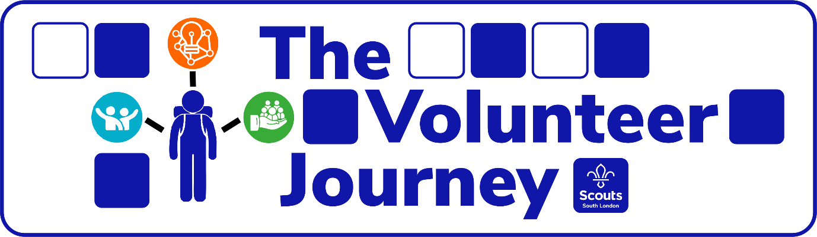

Transforming the volunteer journey and the way we volunteer

Smarter, Better, Easier
It’s important that scouts is a great place to volunteer, where every volunteer matters, and every volunteer has fun. We want to live this in how we treat each other and how we take part and carry out our roles.

This will encourage new people to join us and for those already involved to stick around. We know that in lots of areas, scouts is a great place to volunteer, and our new ways of working will help ensure the great things already happening in some areas are shared and consistent across the UK.

Four: new ways of working:
- a warmer welcome for everyone
- a more engaging learning experience
- simpler roles and structures
- more support to help get everyday things done
Eight: key areas  - Recruitment  - Welcome  - Screening  - Induction | - Personal development & learning  - Volunteer roles  - Our structure  - Digital tools
Three: defined aims
- Work smarter 2. Function easier 3. Be better
Six: clear reasons  - every volunteer is welcomed  - every volunteer is supported  - every volunteer is valued | - every volunteer gains skills  - every volunteer has fun!  - every volunteer matters

Find out more and keep up to date at: www.southlondonscouts.org.uk/people

Got a question? Email us at volunteer.journey@southlondonscouts.org.uk

South London Scouts
South London Scout Centre, Grange Lane, Dulwich, SE21 7LH
0843 289 1548 On social media: @SouthLondonScouts
