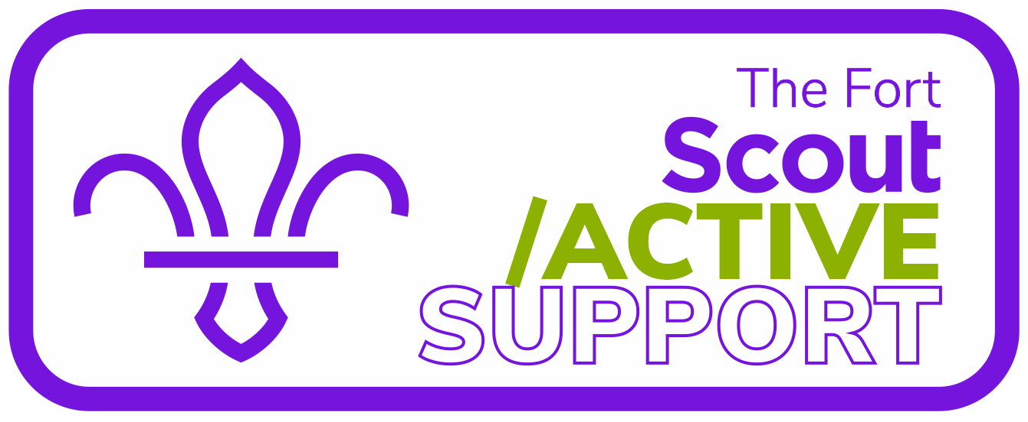

Service Agreement

This agreement is between:

Greater London South County Scout Council
(South London Scouts)

And

The Fort Scout Active Support Unit

Introduction
This service agreement outlines the purpose and active support the fort scout active support unit will provide. How they will support the local needs of the centre management committee and the county executive committee and what the unit members will do over the next twelve months.

This is a living document and subject to regular change and review. It must also assist with the local development needs.

1: The Service Agreement
The South London Scout Centre – The Fort Management Committee has highlighted a need for a team of adults that can provide support to the County and its annual programme of activities and events using a flexible approach to volunteering.

The aim of The Fort Scout Active Support Unit is to provide a flexible volunteering experience to adults that want to support the day-to-day operation and long term development of the centre in a way that suits them and is mutually beneficial to the centre and the county.

In short, the ways that Scout Active Support can aid scouting are almost endless and this agreement sets out in more details the way that The Fort Scout Active Support Unit is organised and its remit.

2: Membership Conditions:
Membership of the unit is permitted on the satisfactorily completion of the Association’s membership appointment process as laid down in the current edition of The Policy, Organisation & Rules of The Scout Association or through already being a member of the Scout Association subject to verification of their current membership.

The team will meet as required in order to carry out training of its members and any other meetings as required to satisfactorily carry out the aims of the team as well as maintaining a social diary.

3: Organisational Structure
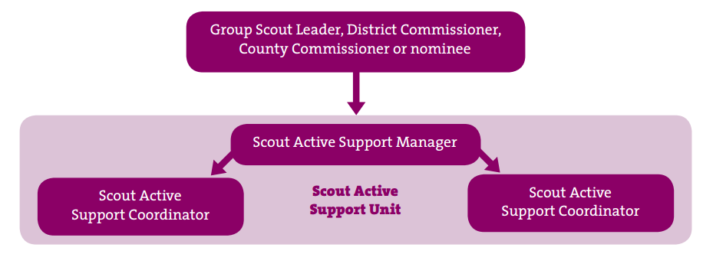

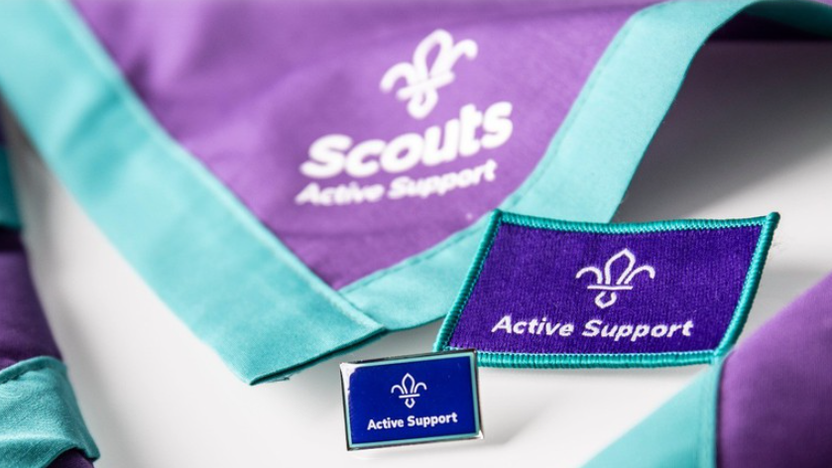
4: Service Provision
No | Need | Method | Target | Completion Date
1
2
3
4
5

5: The Unit’s Five Year Plan 2021-2026
- Increase active membership.

6: Review and Amendments
This service agreement will be reviewed annually prior to the County Annual General Meeting (AGM).

During the annual review the Scout Active Support Manager will meet with and consult the members and obtain their feedback and suggested amendments to this service agreement. Following which a formal recorded review shall be held between the Scout Active Support Manager and Coordinator and the County Chair and County Commissioner.

7: Record of changes
Date | Issue Number | Section | State | Change

8: Approval
Approval between County Commissioner of South London Scouts and The Fort Scout Active Support Manager

 | County Commissioner |  | Scout Active Support Manager
Name
Signature
Date

